

**Artificial Intelligence and Data Science Department CSS/Odd Sem 2024-25/Experiment/MD5, SHA- 1**

|  |  |  |
| --- | --- | --- |
| **Name : Aakash Borji** | **Class/Roll No.:D6ADA/8** | **Grade :** |

# Title :- For varying message sizes, test integrity of message using MD-5, SHA-1, and analyze the performance of the two protocols. Use crypt APIs

**Objective of Experiment :**

1. **Understand MD5:** Grasp the workings of the MD5 algorithm, including its structure and how it produces a 128-bit hash value.
2. **Implement MD5:** Write code to implement the MD5 hashing algorithm and understand its input-output behavior.
3. **Evaluate Security Weaknesses:** Analyze the vulnerabilities of MD5, including known collision attacks, and understand why it is considered weak for cryptographic purposes.
4. **Understand SHA-1**: Learn how the SHA-1 algorithm functions and its design, resulting in a 160-bit hash value.
5. **Implement SHA-1**: Write code to implement the SHA-1 hashing algorithm, examining its input-output characteristics.
6. **Evaluate Security Weaknesses**: Investigate the vulnerabilities of SHA-1, including known attacks like the SHAttered attack, and understand the reasons for its decline in use.

**Artificial Intelligence and Data Science Department CSS/Odd Sem 2024-25/Experiment/MD5, SHA- 1**

# Description / Theory :

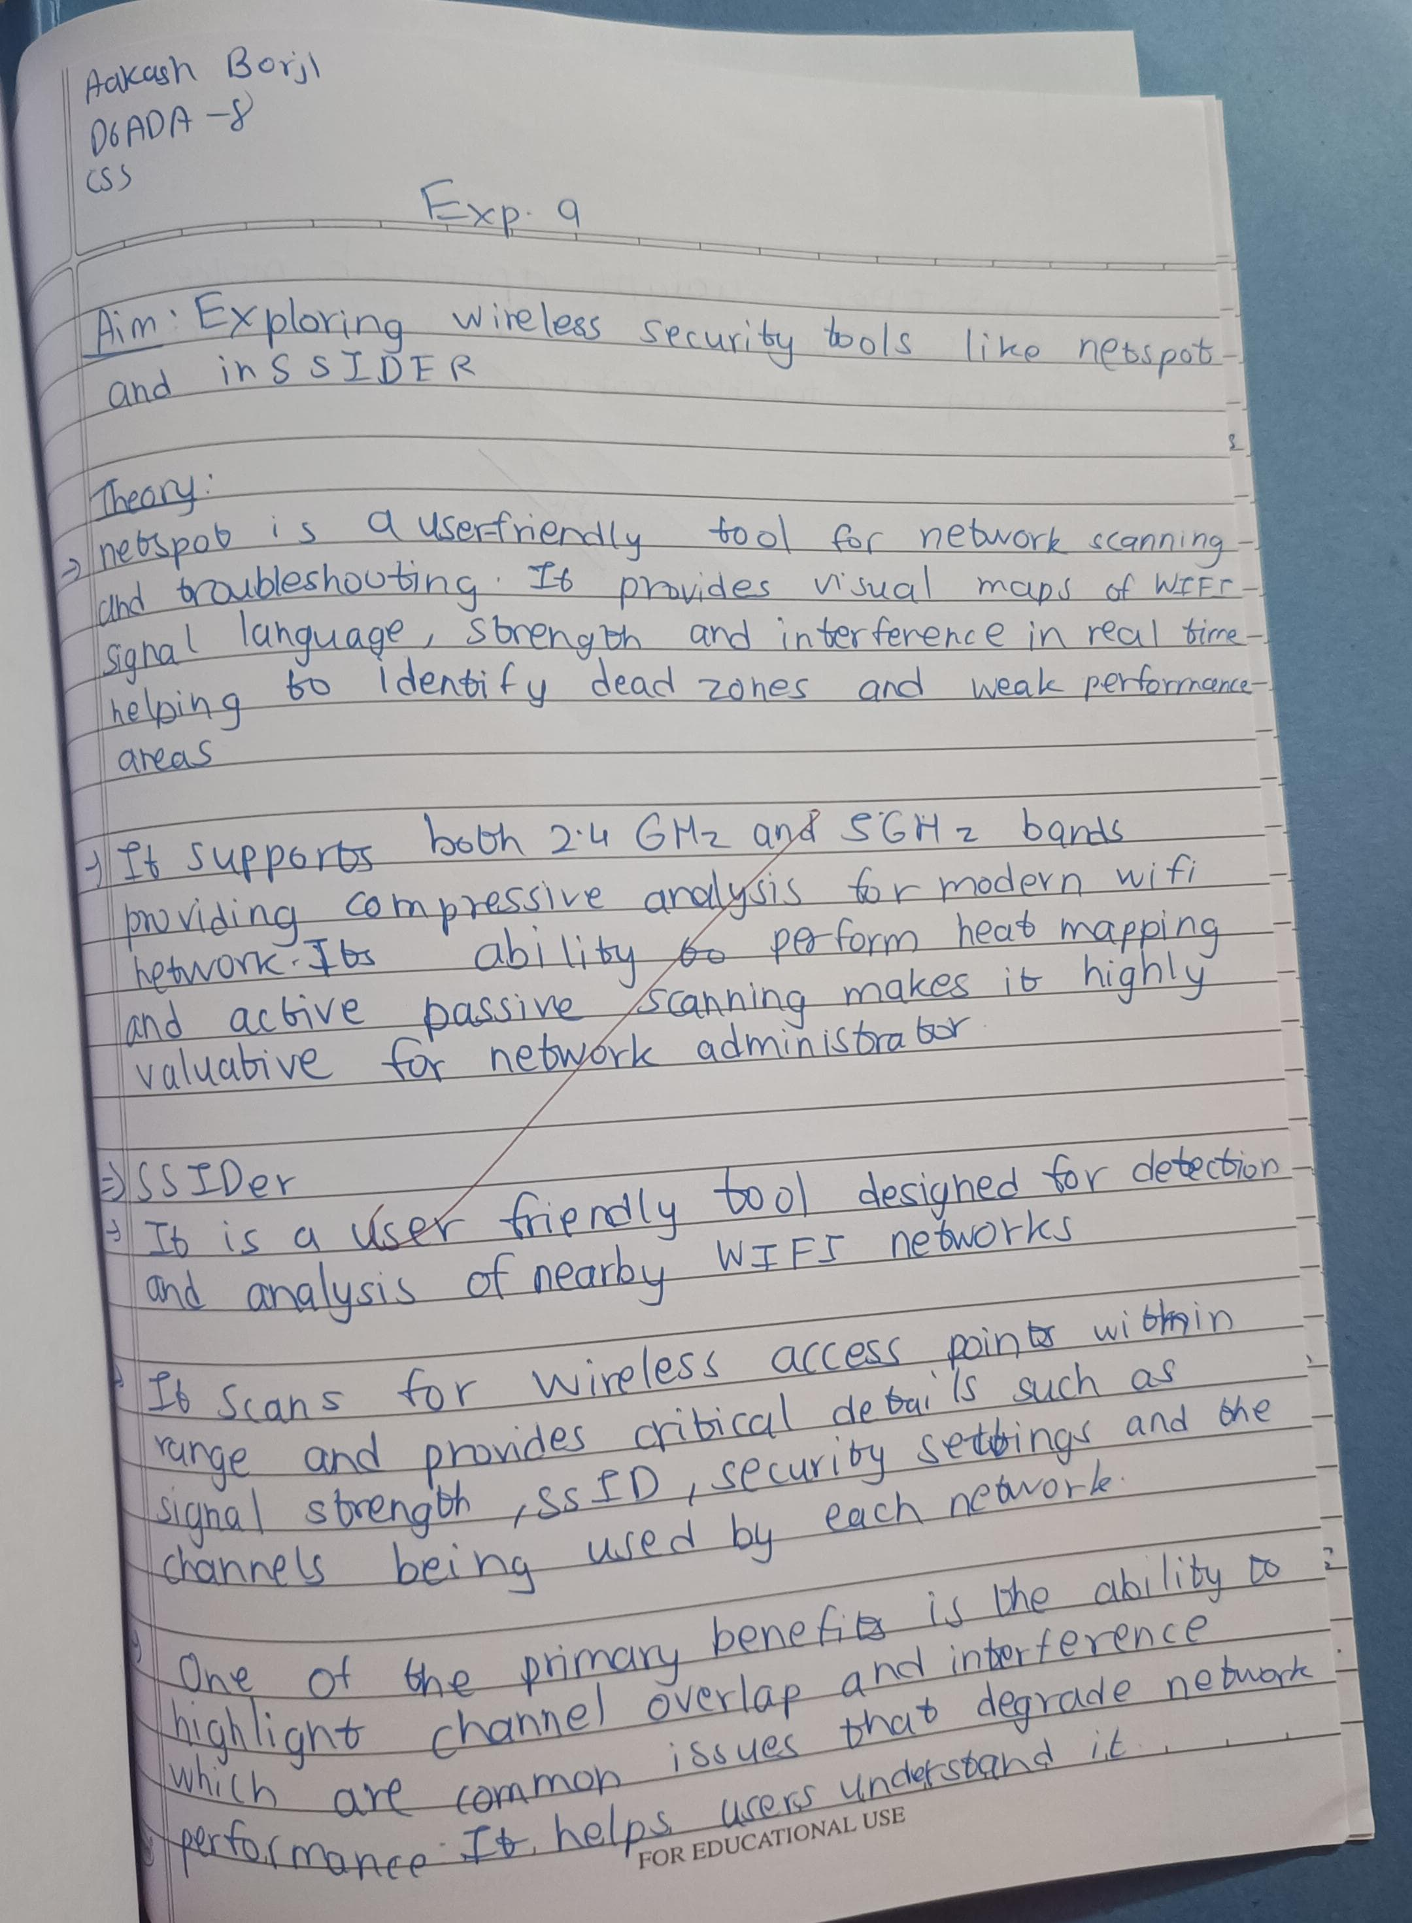

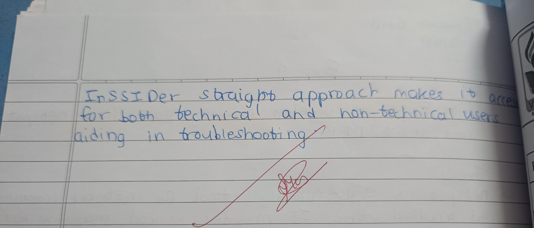



**Artificial Intelligence and Data Science Department CSS/Odd Sem 2024-25/Experiment/MD5, SHA- 1**

# Problem Statement :

1) TIME import time import hashlib

from prettytable import PrettyTable

# Example timing function for hashing

def time_hash_operation(hash_type, data): start_time = time.time()

if hash_type == "MD5": hashlib.md5(data.encode()).hexdigest()

elif hash_type == "SHA": hashlib.sha256(data.encode()).hexdigest()

time.sleep(0.5) # Simulate some processing time return time.time() - start_time

# Simulate some data data_1 = "Hi"

data_2 = "This is a longer paragraph."

data_3 = "This is an even longer page of text that needs to be hashed."

# Measure elapsed times for different operations elapsed_time_1 = time_hash_operation("MD5", data_1) # MD5 elapsed_time_4 = time_hash_operation("MD5", data_1) # MD5 elapsed_time_2 = time_hash_operation("SHA", data_2) # SHA elapsed_time_5 = time_hash_operation("SHA", data_2) # SHA elapsed_time_3 = time_hash_operation("MD5", data_3) # MD5 elapsed_time_6 = time_hash_operation("SHA", data_3) # SHA

# Create the table

myTable = PrettyTable(["Strings", "MD5 Time (s)", "SHA Time (s)", "Difference (s)"]) myTable.add_row([data_1, elapsed_time_1, elapsed_time_4, abs(elapsed_time_1 - elapsed_time_4)]) myTable.add_row([data_2, elapsed_time_2, elapsed_time_5, abs(elapsed_time_2 - elapsed_time_5)]) myTable.add_row([data_3, elapsed_time_3, elapsed_time_6, abs(elapsed_time_3 - elapsed_time_6)])

# Print the table print(myTable)



**Artificial Intelligence and Data Science Department CSS/Odd Sem 2024-25/Experiment/MD5, SHA- 1**

1. LENGTH

from prettytable import PrettyTable import hashlib

# Function to compute hash lengths def get_hash_lengths(text):

md5_hash = hashlib.md5(text.encode()).hexdigest()

sha256_hash = hashlib.sha256(text.encode()).hexdigest() return len(md5_hash), len(sha256_hash)

# Strings to be used in the table strings = ["Hi", "Paragraph", "Page"]

# Compute hash lengths for each string len_1, len_4 = get_hash_lengths(strings[0]) len_2, len_5 = get_hash_lengths(strings[1]) len_3, len_6 = get_hash_lengths(strings[2])

# Specify the column names while initializing the table

myTable = PrettyTable(["Strings", "MD5 Length", "SHA-256 Length"])

# Add rows

myTable.add_row([strings[0], len_1, len_4]) myTable.add_row([strings[1], len_2, len_5]) myTable.add_row([strings[2], len_3, len_6])

# Display the table print(myTable)



**Artificial Intelligence and Data Science Department CSS/Odd Sem 2024-25/Experiment/MD5, SHA- 1**

1. HASH

import hashlib

str1 = "Hi" str2 = "Ho" str3 = "CSS" str4 = "DSS"

result = hashlib.sha512(str1.encode())

print("The hexadecimal equivalent of SHA512 for 'Hi' is: ") print(result.hexdigest())

result = hashlib.sha512(str2.encode())

print("The hexadecimal equivalent of SHA512 for 'Ho' is: ") print(result.hexdigest())

result = hashlib.md5(str3.encode())

print("The hexadecimal equivalent of MD5 for 'CSS' is: ") print(result.hexdigest())

result = hashlib.md5(str4.encode())

print("The hexadecimal equivalent of MD5 for 'DSS' is: ") print(result.hexdigest())



**Artificial Intelligence and Data Science Department**

**CSS/Odd Sem 2024-25/Experiment/MD5, SHA- 1**

**RESULTS:- 1.**

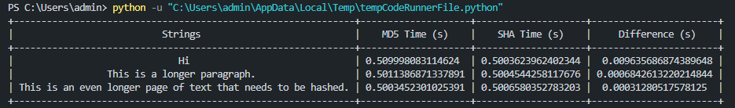

**2.**

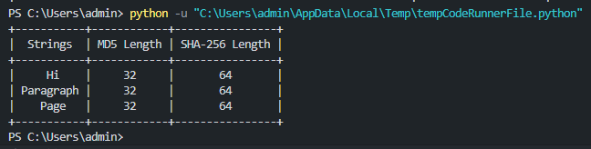

**3.**

